Research is a time-consuming process, and can become very frustrating. Follow these steps to make your life as a researcher much easier!
- PLAN – Research is a process. Developing a plan before you dive in helps you stay focused and on schedule.
- TIME MANAGEMENT – Researching a project can be very time-consuming. Don’t wait until the night before! Even if you only need 4 articles, you might need to review 40 before selecting the best ones. And, interlibrary loan requests for items the library does not own can take a few days.
- NOTES – If you find research frustrating, taking better notes can help save the day. No more lost articles or forgotten databases. Write down search terms you’ve tried, databases that have been useful, and articles that seem relevant. Jot down a few words to describe each article so you don’t have to read it again and again. Refworks is a good place to store article citations.
- ACADEMIC INTEGRITY – Be aware of academic integrity guidelines, and be sure to cite all of your sources properly.
- LIBRARIANS – Ask a librarian for help! Subject librarians are available by phone, email, instant messaging, or in person.
_______________________________________________________________________________________________________________________________________________________________________________________________________________________________________________________________________________________________________________________________________________________________________________________________________________________________________________________________________________________________________________________________________________________________________________________________________________________________________________________________________________________________________________________________________________________________________________________________________________________________________________________________________________________________________________________________________________________________________
Questions? Contact
Kristyna Carroll
kristyna.carroll@villanova.edu
610-519-5391

RefWorks
To access RefWorks
Falvey homepage (http://library.villanova.edu) Databases A-Z RefWorks
- Then sign up for your personal RefWorks account
View the Step-by-step tutorials:
http://www.refworks.com/tutorial/
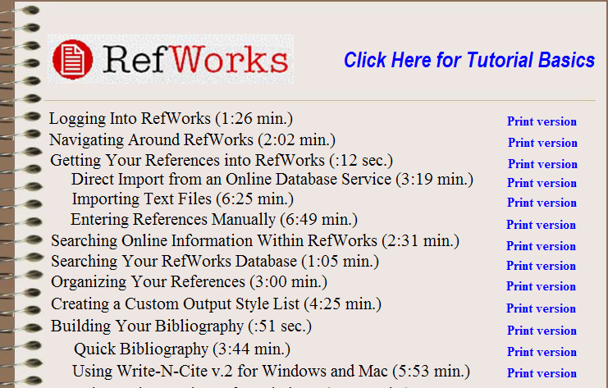

When you’re ready to type your first paper…

Download “Write-N-Cite” available under Tools in your RefWorks account.
- Villanova group code: RWVillanovaU

bq - 1/2009

